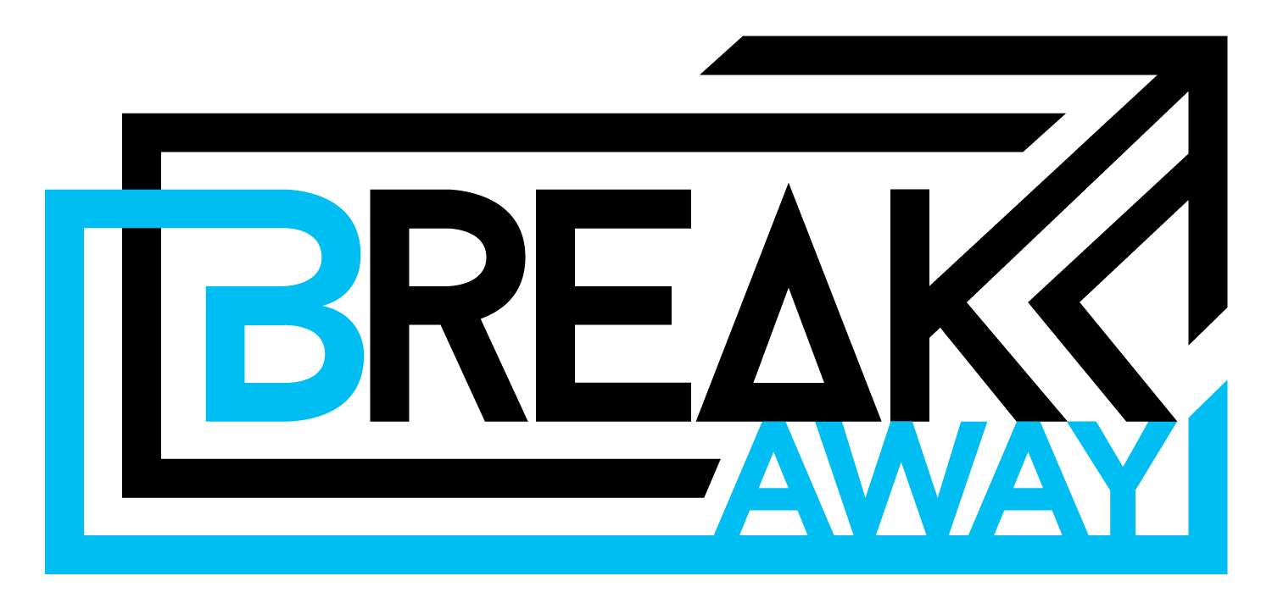
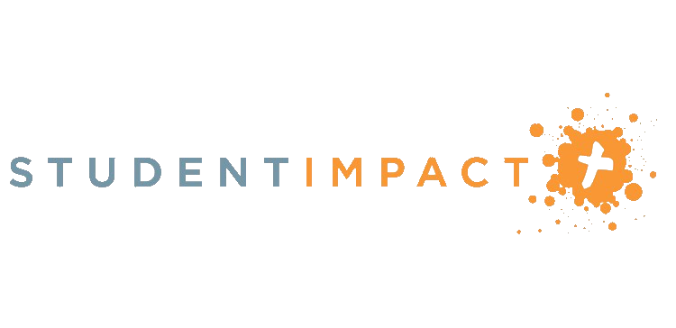

High School Ministry Trip
June 28 – July 3

Toronto Remix
an urban mission designed to create
a disciple-making movement
2020 HS STUDENT IMPACT
MINISTRY TRIP

We have postponed our planned trip to the DR until next summer and instead are offering a new trip…Toronto Remix!

Eligibility: current 9th -12th graders

What: a week-long interactive and hands-on urban mission experience designed to equip, train, and inspire young people to center their lives within the mission and message of Jesus. Each participant will receive in-depth training each day, be engaged in afternoon mission opportunities throughout Toronto and be a part of large group celebration gatherings each evening.

Cost: The of the trip is $499 plus meals while traveling

Requirements- I am committing to fulfill the pre-trip team requirements:

- attend an informational meeting with at least one parent
April 19 @ 5 pm at church

- read the short book provided after you apply
- pray for the financial need of each team member
- enlist the prayer support of at least three non-relatives
- participate in the group fundraising events

To participate, complete both sides of the Remix Application Form on the next page and turn it in with a $100 deposit by Sunday, March 29th.

**make checks payable to North Park Baptist Church

** If you had applied for the DR Trip and turn in a Remix Application Form, we will automatically apply your deposit to Remix unless otherwise indicated.

